

Gator-Gasp

Particulate Matter Datalogger for Field Applications



Contacts:

*Dr. Rafael Muñoz-Carpena – carpena@ufl.edu*

*Rio Bonham – r.bonham@ufl.edu*



**Statement of Purpose**

Gator-Gasp serves as a low-cost and ease of use datalogger for Particulate Matter measurements for field applications. The sensor is split into three components: the slider (blue composite piece):

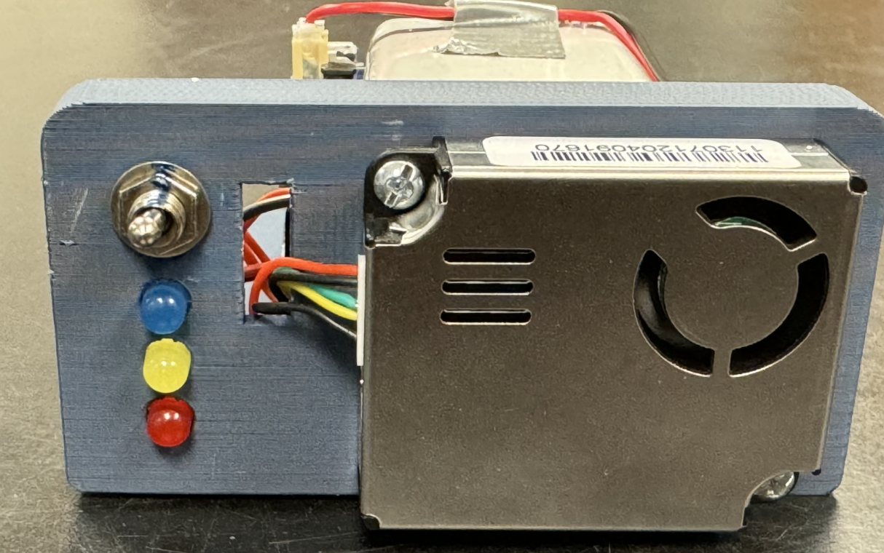

shell (orange composite piece):



and weather housing.

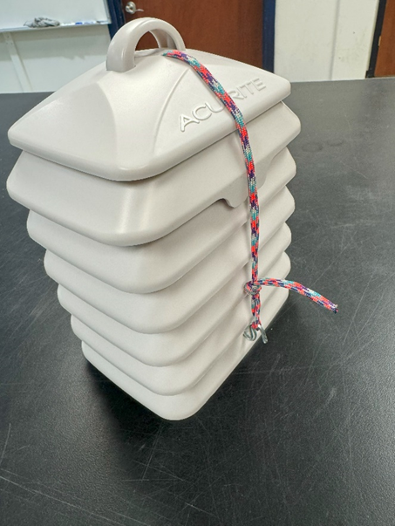

The slider component holds the electronic portions of the sensor (circuits, SD card, battery, etc.), whilst the shell is primarily a socket for the slider to make a joint box (as seen on the cover page). This combination between the blue slider and orange shell creates a ‘mold’ to appropriately fit inside sensor housing. There is a thin rope going through the weathering housing meant to hook onto the ‘cleat’ of the blue slider (see Quick Start step 5). This rope will reliably hold the sensor inside the weathering housing and can be hooked to a metal loop on the outside of the weathering housing (see Quick Start step 6). The operation philosophy for Gator-Gasp is centered around user-based interactions for ease of use. The quick start guide below are all the steps required to begin collecting data and the files are securely saved on the SD card after being finished.

Please see additional details on the particulate matter air sensor PM2008 used in GATOR-GASP: <https://www.co2meter.com/products/particulate-matter-cubic-sensors>  
**Quick Start**

1. Make sure SD Card is inserted.  
   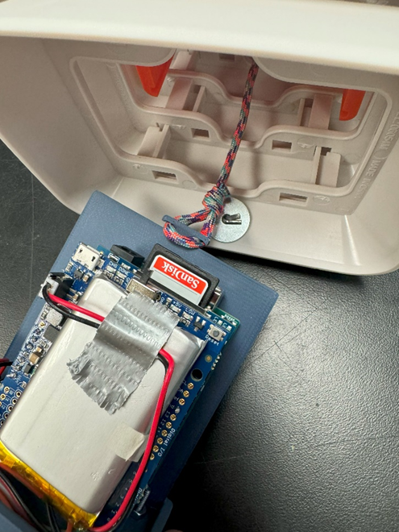
2. Turn on the Power Switch.  
   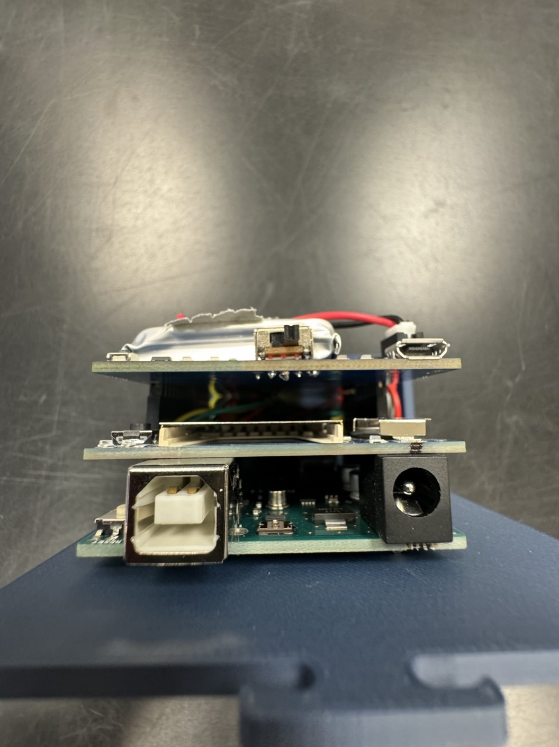
3. Turn on the Sensor Switch (flipped away from the LEDs).  
   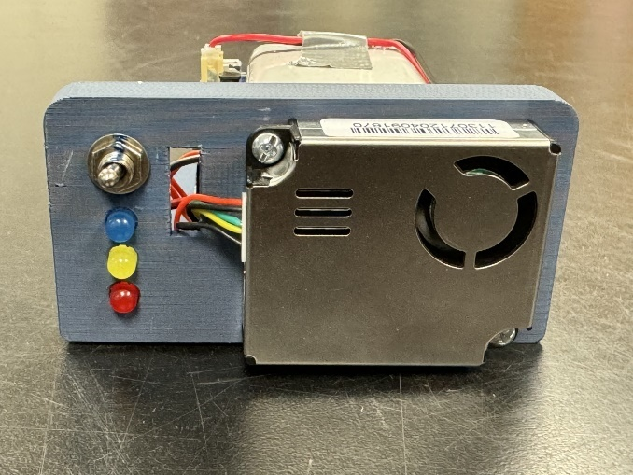
4. Wait for the blue LED to finish flashing.  
   
5. Hook the strap to the blue casing and slide the orange & blue back into the sensor casing  
   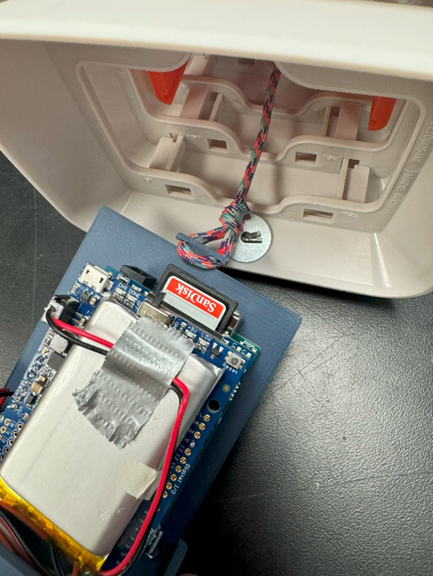
6. Slide the orange & blue back into the sensor casing and pull on the thin rope and loop around the metal hook.  
   
7. Finishing logging? Just do these steps in reverse! (Note: you can flip the Sensor Switch, see step 3 above, from the bottom of the weather housing, so the user doesn’t have to undo the entire contraption between trials)

**Important Information**

**\***Always stop data collection before powering the sensor off. This means first toggle the sensor switch off (see Quick Start step 3, flipped towards the LEDs) and then the user may turn off the power switch (see Quick Start step 2).

*This sensor is not water-proof despite being inside a weather-proof casing and should not be operated while it is raining.

**LED Guide**

|  |  |  |
| --- | --- | --- |
| **Color/Status** | **Meaning** | **Required Action** |
| Flashing Blue | Sensor is warming up. | Wait for warm up period to complete. |
| Solid Blue | Data is being logged successfully |  |
| Solid Yellow | Low Battery Warning | Recharge battery ASAP |
| Solid Red | SD card not found | Insert SD Card, then datalogger turn off and back on. |
| Flashing Red | Clock Error | Contact Rio |
| Solid Blue & Red | SD error in logging | Wait to see if it happens again (it has a self-fix). If issue persists, reinsert SD Card and restart. |

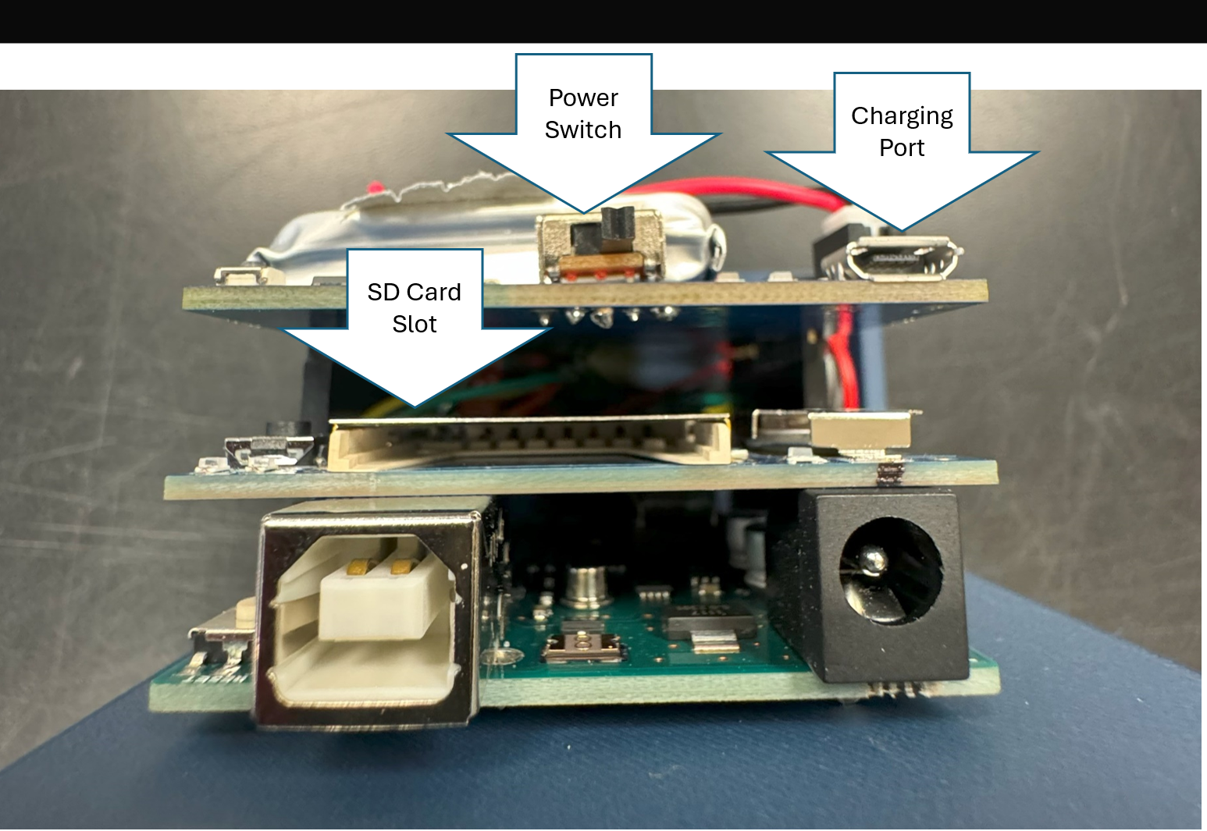

**Gator-Gasp Operation**

**Charging Datalogger**

1. Plug micro-USB cable into appropriate port.
2. ‘Done’ green LED light will illuminate near the battery when fully charged.

**Turning On Datalogger**

1. Make sure SD card is fully inserted.
2. Toggle Power Switch (see Quick Start step 2) directly above SD card slot. A small blue LED should turn on to the left of the switch.
3. Power drain is low while Datalogger is powered on, can last more than 24 hours (although this is not recommended to do). Most of the consumption will come by powering the Sensor on (see Quick Start step 3) and will last approximately 8 hours while the Sensor Switch is on (flipped away from the LEDs).

**Installing Datalogger inside Housing**

1. Attach internal string loop to cleat on blue datalogger board (see picture below on the left).
2. Insert datalogger board into the housing, making sure to align it in the slots of the internal orange shell.
3. Secure external string loop to hook on housing side (see picture below on the right).

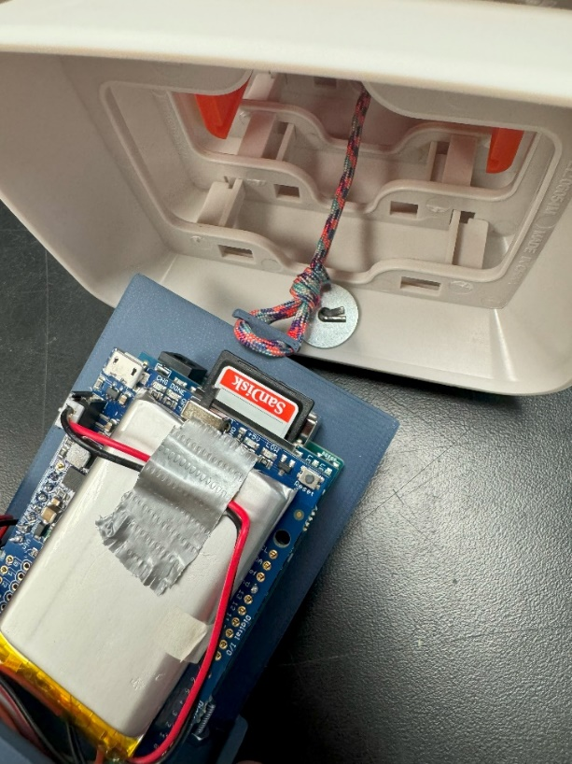*If the orange shell also comes out, it is not a problem. Just be sure to reinsert the box in the proper orientation. The rope/cleat should be on the side closest to the external metal hook, or else the rope may not be long enough for it to be properly secured.

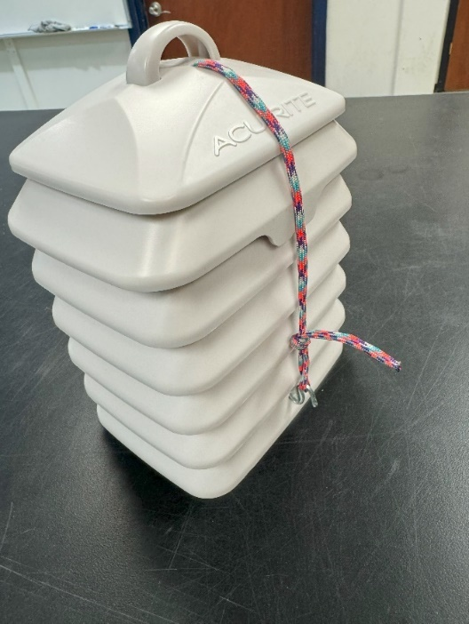

**Starting Data Collection**

1. Toggle Sensor Switch on (see Quick Start step 3 and flip away from the LEDs) on bottom of datalogger board next to sensor up away from the LEDs. The external blue LED will begin flashing after a few seconds to indicate the sensor is warming up.

*Up to a 15s delay between toggling external switch and the LED responding is normal (both when turning data collection on or off).

1. **WAIT** for LED stop flashing before beginning sampling period! The datalogger is NOT collecting data until the LED is solid blue.
2. Once the LED is solid blue, sampling period can begin. After sampling period, stop data collection by toggling external switch again.

**Downloading Data**

1. Ensure datalogger is turned off, then remove SD Card.
2. Plug SD card into computer and open file explorer/finder. There should be two csv files: X_data & X_bdata, where X is unit number ID. These files should be identical (bdata is just a backup of data).

*The sensor works by counting the number of particles of each size range (count/.1L). It then plugs these values into a calibration function (referenced to an unspecified GRIMM instrument) to return the concentration in µg/m3.

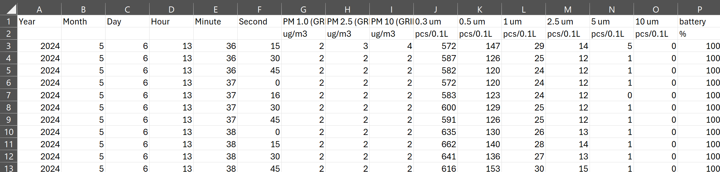

**Troubleshooting**

*Resetting the Datalogger*

If there is unexpected behavior not specified here, such as blue LED not coming on when collection switch is flipped, you can try resetting the datalogger. FIRST make sure data collection has been stopped, then switch the power on and off. If that does not solve the issue, please contact Rio Bonham (Ph.D. student at UF at [r.bonham@ufl.edu](mailto:r.bonham@ufl.edu) or 580-380-5775)

*Recalibrating the internal clock*

Over an extended of period time and use, drift may occur, and it may be necessary to reset the internal clock. This is a more complex sequence of steps and will require an individual with intermediate computer skills (download Arduino IDE & upload the script). The GitHub (which has all necessary files and information) will specifically outline how to do this at this link: <https://github.com/marioblue5/PM-Logger>

Enter the troubleshooting folder and scroll down until you see “recalibration of the RTC” (real-time clock).